Posted 12/03/2015 at 9:46 am by JAV

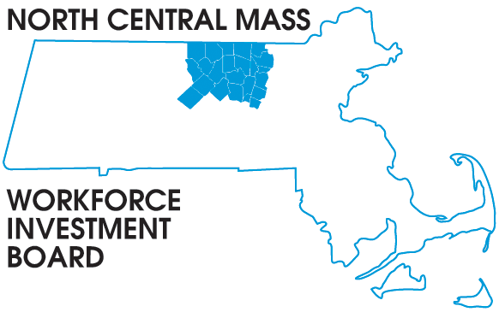
1355 Central Street Leominster, MA 01453 Phone: (978) 534 1023 Fax: (978) 534 1807

BOARD OF DIRECTORS MEETING

Tuesday, December 8, 2015

North Central Chamber of Commerce
860 South Street Fitchburg, MA
8:00 a.m. – 9:30 a.m.

AGENDA

Welcome & Introductions

Approve Minutes of the September, 2015 meeting (Vote required)

Executive Committee report Theresa Kane (Vote required)
Finance report Barbara Mahoney

Presentation

WIOA Strategic Planning
Process and Activities
Theresa Kane & Mike Noble

Grant Updates:
School to Career-Mike Gerry
DEI-V Theresa Kane
NEG Sector- Tim

Directors Report: WIOA implementation & Workforce in the NEWS

Other Business

